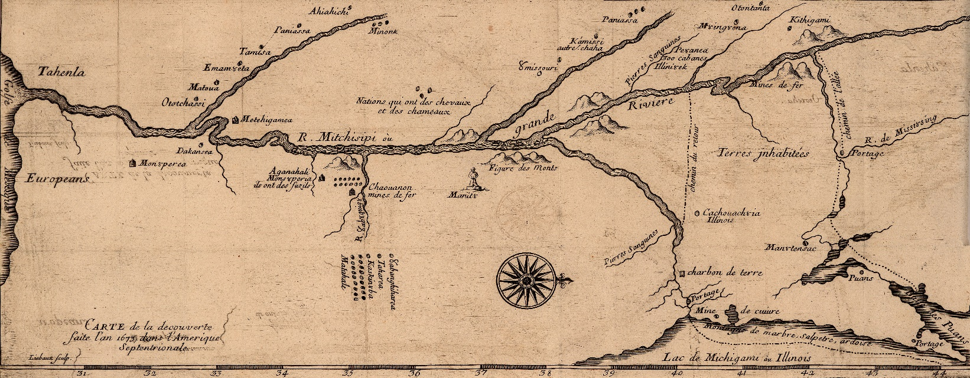

**Home Vita Publications Public Talks Consulting & Media Contact**

**Consulting & Media**

Over the years, I have provided historical research support to a variety of organizations. I also have been interviewed for historical documentaries, newspaper articles, and radio and television shows. I am always willing to consider any consulting job or media appearance. Read below to see what I have done.

Click here if you would like to contact me about a consulting opportunity or schedule a media appearance.

**Consulting**

**Door County Maritime Museum, Sturgeon Bay, Wisconsin, 2021**

Currently, I am providing research support to the Door County Maritime Museum concerning the Native American presence on the Door County Peninsula from prehistoric times to the present. This research is part of the museum’s ongoing effort to update its various displays and exhibits.

**Richfield Historical Society, Richfield, Wisconsin, 2020**

For this project, I researched the French missionary explorer Jacques Marquette and his supposed visit to Holy Hill, a religious shrine in southeastern Wisconsin. My research resulted in the publication of a booklet that examines the veracity and origin of this legend.

**Preserve Our Parks, Milwaukee, Wisconsin, 2013-2015**

This non-profit organization asked me to research the historic development of the Lake Michigan shoreline. Preserve Our Parks works to maintain land for public use. The organization sought to prevent the private development of a parcel of land along the Lake Michigan shoreline and used my research in courtroom litigation.

***History Detectives*, Lion Television, New York, New York, 2010**

Lion Television produces a variety of television shows, including those that investigate historical mysteries. I provided information concerning the 1827 Winnebago Uprising for an episode of the show *History Detectives*.

**Potawatomi Treaties Research, Lord Cultural Resources, Inc., Ontario, Canada, 2001**

I researched the treaties signed by the Potawatomi Indians of the United States and Canada throughout their history. Lord Cultural Resources used my research to produce a museum display for the Forest County Potawatomis of Wisconsin.

**Media Appearances**

[***Secrets of the Viking Stone: The Kensington Runestone***](https://www.imdb.com/name/nm12423677/?ref_=tt_cl_t_12)**. Science Channel, 2021**

This documentary, produced by Viking Brothers Entertainment of Los Angeles, California, examines the mystery surrounding the enigmatic Kensington Runestone. Did medieval Vikings produce this famous artifact, or is it an elaborate hoax? This documentary examines the issue, and I provide information on the experiences of later French explorers in the Great Lakes as a counterpoint to the earlier Vikings. The first episode aired on January 3, 2021 on the Science Channel.

[***The Battle of Wisconsin Heights***](https://www.wpr.org/shows/battle-wisconsin-heights-0)**. University of the Air, Wisconsin Public Radio, 2019**

The Battle of Wisconsin Heights was the most dramatic event of the Black Hawk War of 1832. In this interview, I discuss the roles of famous figures such as Henry Dodge, later the governor of Wisconsin Territory, and the Sauk leader Black Hawk. The interview is available online and first aired on May 5, 2019 on WERN, Madison, Wisconsin.

[***Researcher Says Jean Nicolet Was a Diplomat, Not Explorer***](https://fox11online.com/news/local/researcher-says-jean-nicolet-was-a-diplomat-not-explorer)**. WLUK, Green Bay, Wisconsin, 2019**

This television news segment explores my research on Jean Nicolet, the first European to visit Wisconsin. This segment is available online and first aired on June 25, 2019 on Fox 11 WLUK in Green Bay and Fox 55 WFXS in Rhinelander and Wausau, Wisconsin.

[***Famed French Explorer Jean Nicolet Gets a Historical Revision***](https://madison.com/wsj/news/local/famed-french-explorer-jean-nicolet-gets-a-historical-revision/article_ee5baffe-aba9-5d6c-98f5-d5ab33a8a7ff.html)***.* Wisconsin State Journal, 2019**

This newspaper article discusses the publication my recent book on Jean Nicolet. The article is available online and first appeared in the *Wisconsin State Journal* on June 23, 2019.

[**Grohmann Museum Addresses Life of Controversial Nazi-Era Artist Erich Mercker**](https://archive.jsonline.com/entertainment/arts/biography-begins-but-doesnt-complete-portrait-of-nazi-era-artist-erich-mercker-b99399211z1-284815251.html/)**. Milwaukee Journal Sentinel, 2014**

This newspaper article examines my research on the German artist Erich Mercker and an exhibition of his work at the Grohmann Museum in Milwaukee, Wisconsin that I curated to promote the publication of my biography on Mercker. The article is available online and first appeared in the *Milwaukee Journal Sentinel* on December 9, 2014.

[***Jean Nicolet’s Misunderstood Mission***](https://www.wpr.org/shows/jean-nicolet%E2%80%99s-misunderstood-mission)**. Larry Meiller Show, Wisconsin Public Radio, 2019**

In this interview, I discuss the life and career of the first European to arrive in Wisconsin, Jean Nicolet. The interview is available online and aired live on April 2, 2019 on WHAD, Milwaukee, Wisconsin.

[**Wisconsin Legends: Chief Black Hawk**](https://www.wpr.org/wisconsin-legends-chief-black-hawk)**. Central Time, Wisconsin Public Radio, 2014**

This interview examines the life and times of Black Hawk, a war leader among the Sauk Indians. Much of the interview focuses on the role he played in the 1832 war that bears his name. The interview is available online and first aired on December 4, 2016 on WERN, Madison, Wisconsin.

[***Nicolet—The Man and the Legend***](https://www.wpr.org/shows/nicolet-man-and-legend)**. University of the Air, Wisconsin Public Radio, 2013**

Much of what is known about Jean Nicolet remains a mystery. This interview discusses what we know, what we do not know, and the myths and legends that surround this enigmatic figure who came to Wisconsin in 1634. The interview is available online and first aired on July 28, 2013 on WERN, Madison, Wisconsin.